This is a sample of the resources Legato Strategic Consulting provides through dedicated support to institutions like yours.

National Student Clearinghouse Enrollment Reporting
Lessons Learned, Advice, Steps

Background
The National Student Clearinghouse (NSC) Enrollment Report is one of the most consequential compliance reports an institution submits. It determines whether students remain eligible for federal financial aid, loan deferment, and continued enrollment status in the eyes of the U.S. Department of Education.

In legacy SIS environments, this report was often a vendor-controlled “black box.” Institutions could not easily view or verify what was being sent to the Clearinghouse. With Workday Student, that has changed. Every configuration choice—from how a Program of Study is defined to how a student’s completion date is recorded—is now visible and under institutional control.

That visibility is empowering but also demanding. Institutions now bear full responsibility for both the data and the compliance outcomes. Achieving an accurate, audit-ready NSC report typically requires at least 100 hours of cross-functional effort from Records, Financial Aid, and Institutional Research teams during implementation and testing.

The National Student Clearinghouse Enrollment Integration (but really a report) is a “track changes” report. This means that you have to put in data about when the last time you ran the report is. Then it will calculate changes in students’ primary program of study status (e.g. In Progress to Institutional Withdrawal), load status, change of program of study. It reports status dates for any of those changes.

Begin testing this as soon as you have the configuration and data conversion prerequisites met. Use this data to help validate your data conversion and configuration.

Preparation Steps
- Review the National Student Clearinghouse Guide: https://theclearinghouse.download/erguide

- Review the Workday National Student Clearinghouse Connector Guide.
  - Make sure to address all set-up. For example, the “Special Program Indicator” field has configuration that must be done in the Financial Aid workstream. They may not realize the NSC impacts of that configuration. Go through the guide and highlight all configuration tasks. Review the tasks before testing.

- Meet with your NSC representative. Find out which fields in the NSC Enrollment Report are required for you to submit.

- Determine which programs of study you need to report (in Workday Program of Study language).
  - Avoid reporting Programs of Study unless they are required. For example, minor or concentrations may not need to be reported.

- Have your Implementation Partner set up the NSC Enrollment integration in your tenant.
  - Do not have anything be automatically sent to NSC. The integration is just enabling you to run a report. You need to have significant data validation before each submission.
  - Review NSC set-up guide in Community:
    - The set-up is NOT that technical. It can be understood and configured by a high-end power user. Your integrations lead should not be working on this independently. They should collaborate with your lead for NSC Enrollment.

- Configure your NSC Enrollment integration (report) in Workday to only report the required fields (as determined in Step 2).
  - Right now Workday struggles with this. Currently testing a workaround of putting in a special character for optional fields. Some are set-up in the configuration with the option to be optional. Some fields that NSC said could be optional are still required by Workday.

- Build your Excel skills
  - Schools report that the Workday output is a basis for their submission. They are doing sometimes extensive edits in Excel (the goal is that it should be none to minimal).
  - Excel skills needed: VLOOKUP formula, managing data in a .txt format, comparing data.

- Build a validation report in Workday that pulls data using the Academic Period Record data source and uses the Student business object for any PII data:
  - Match the columns in the National Student Clearinghouse report as best as you can. Add in additional data to help you make sure you have everything accurate in your put

- Get from Legato an Excel version of the NSC Enrollment guide. We have built a header row so that you can actually understand the file output from Workday.
  - Do not export using Workday’s Excel version. Only use their .CLR version and convert to .txt

Set-up Pre-Cursors to Testing National Student Clearinghouse Enrollment
- Programs of Study Definitions
  - If you decide not to report certain programs of study, make sure to check the boxes of any programs of study you don’t want to report or any populations of students (e.g. students in a 3+2 program that should not be reported as they are actually attending another institution).
  - CIP codes on all Programs of Study being reported
- Load Status Policy
- Class Standing Policy
- The following data conversion workbooks must be loaded into your tenant:
  - Student Personal Information (SPI)
  - Matriculations
  - Program of Study Snapshot
  - Registrations
    - Make sure to convert students with enrolled coursework so that you can see these registrations show up in the NSC report.
  - Course Definitions
  - Course Sections
- Maintain Citizenship Statuses
- Military Statuses (if reporting Veteran’s Status Indicator)
- Pell Grant information (if reporting Financial Aid)

- Application CEEB Code (if reporting High School CEEB) – this must come from the application, not the educational institution on the Student record
- Maintain Federal Student Aid Program Policy – this is to set up the Special Program Indicator – This is required for all programs you report.

Considerations
- If you want to report Race/Ethnicity, there are several issues and set-up:
  - Make sure that your set-up allows for both workers/students to select more than one race. Do not have an option for “Two or More Races” on the Maintain Ethnicities task. If HCM set this up, get this fixed before starting Student data conversion.
    - Two or more races should be a calculated field. More on that below.

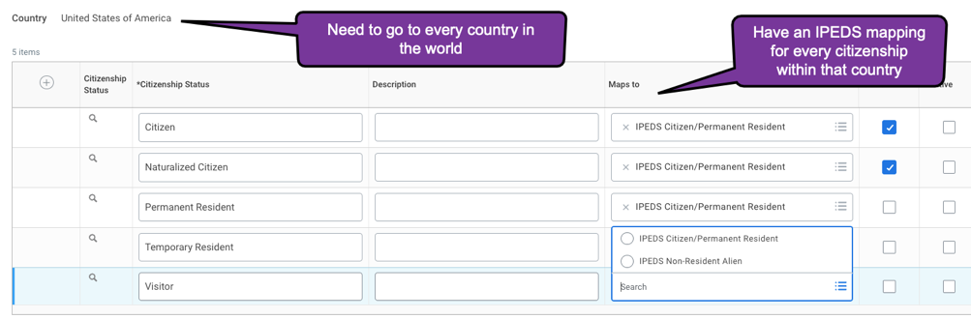

- To have Workday’s calculated field for IPEDS race even have a chance of working correctly, you have to have to go to EVERY country in the world and map every citizenship status in that country to an IPEDS mapping.
  - Schools often make the mistake of only mapping the country of United States. If you do this then you will not have a correct IPEDS race display in the NSC output.
- There have been issues of Workday still not calculating IPEDS race correctly for students with multiple citizenships. Make sure to test this extensively. If you cannot get the Workday IPEDS race to be correct, you can use a calculated field.

Additional Notes
- NSC doesn’t allow special characters. Makes sure you remove any in your file.
- Commas will throw off your file and cause data to be submitted in an incorrect column. Search your file and remove them. A “-“ a the end of a cell may also throw off spacing when submitting to NSC. Check your address and city columns.
- Make sure to review in detail the Workday guide.
- Only 30 characters allowed for an address. Otherwise it will shift all your data over. Workday doesn’t allow 30 characters and will cut off the address.
- Any quotations in addresses will cause issues. Quotations may appear if you have a comma.
- Any letters with accent marks will cause issues
- In column BD “Special Program Indicator”

NSC Dates to Consider
- For the “W” date, loan services want to have the last day of attendance/activity.
- For the “G” status, it is best practice to use the Program Completion EIB. It allows you to set your Program of Study Effective Date as the last day of classes. This is needed for NSC Enrollment reporting as well as for other financial aid requirements.

  - The field on the EIB (an Excel way to load in data to Workday) is:

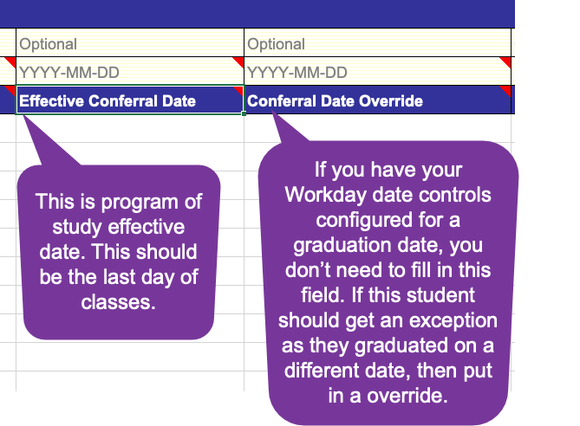

  - The label of “conferral” is confusing as it has a technical meaning in Workday. It is from testing that I am documenting that the “Effective Conferral Date” is actually Program of Study Status Effective Date.
  - Conferral Date Override is the actual field to override a date control for the conferral date.

- Other systems like Banner may have reported the program of study status change date as the start of classes (back-dating it for students). Workday will report the actual date. If you get errors, you should just accept the error and tell NSC that this is the new date that you want to report.

